### Lightning App

### Create The Event Management App

|  |  |
| --- | --- |
| Team id | AD47707C5D4D5109D5E480002BDB30D5 |
| Project Tittle | Build an Event Management System using salesforce |

### Screenshot (20).png

1. From Setup, enter App Manager in the Quick Find and select App Manager.
2. Click New Lightning App. Enter Event Management as the App Name, then click Next

### Screenshot (22).png

1. Under App Options, leave the default selections and click Next.
2. Under Utility Items, leave as is and click Next.

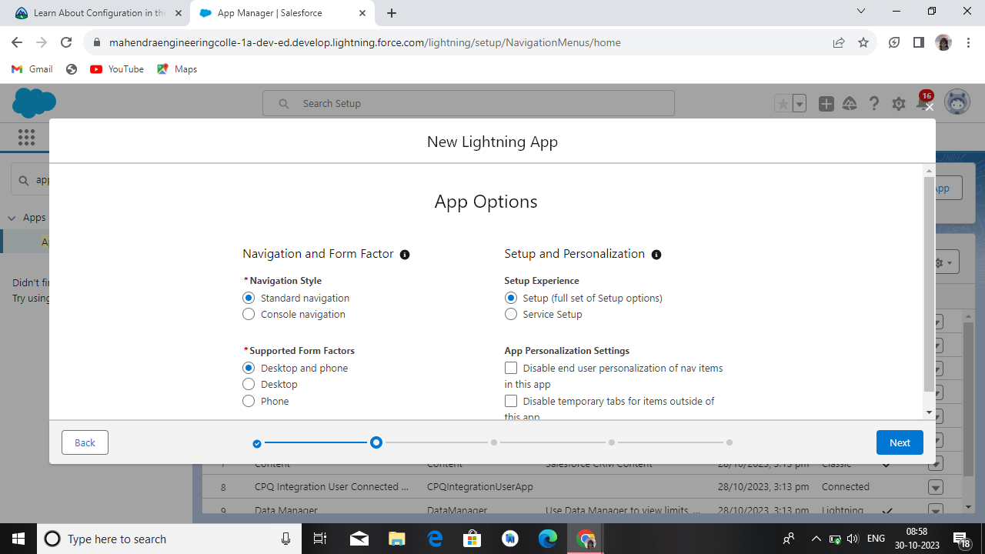

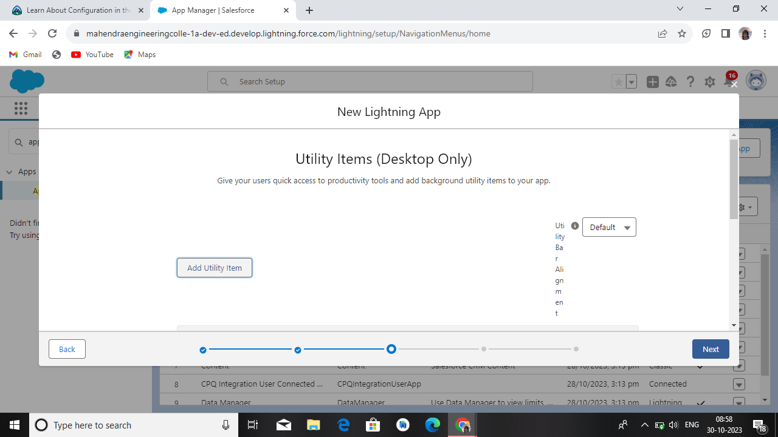

1. From Available Items, select Occasions, Attendees, speakers, vendors, Event Service,
2. Reports,and Dashboards and move them to Selected Items.
3. Click Next.
4. From Available Profiles, select System Administrator, Custom standard user and move it to Selected Profiles. Click Save & Finish.

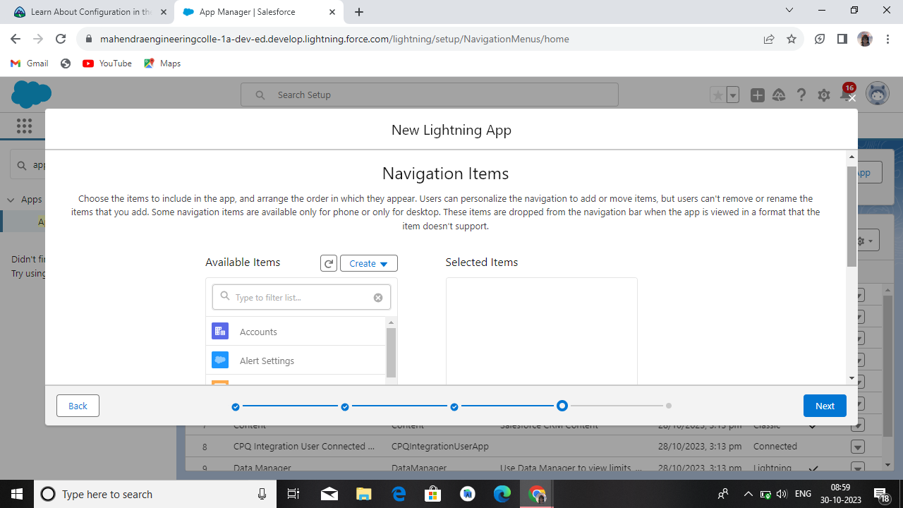

### Screenshot (29).png